System Model:
Introduction
Individuals who are knowledge workers in a knowledge economy may find themselves, at different times and sometimes simultaneously, self-employed, working in an ad hoc network, or earning a salary with an organization. To be successful, they need to have a sense of how different aspects of knowledge management fit together as they guide their own career paths and find ways to add value to ad hoc and formal organizations.
In Western countries, an increasing proportion of the workforce is employed for their knowledge. That knowledge is for the most part up to individuals to acquire and maintain, and it is largely portable. It may be of content or process, tacit or explicit, general or particular, linear or relational, timeless or up to the minute. It is utilized by individuals working alone and in small groups or large organizations. Especially in the private sector, many knowledge workers are self-employed or members of ad hoc virtual or network organizations rather than permanent salaried employees.
The knowledge marketplace is not always a comfortable place for the individuals involved. They may suffer the disadvantages of insecurity and cost absorption which have traditionally been associated with the secondary labor market. The short term arrangements common today effect individuals differently. The same circumstances that provide flexibility and adventure for the young single professional may be highly stressful for someone with a family and a mortgage. These are important considerations: not only for the more independent knowledge worker, but also for the large and small organizations who outsource functions and contract for specialized talent and the networks which provide it. At a minimum, temporary and contract workers must have opportunities to keep their skills up to date to avoid depletion of the talent pool. If organizations are not offering the security of long term employment, other provisions must be made which do not simply download the costs of knowledge maintenance to those individuals least able to afford it.
The Value of Knowledge and Intellectual Capital
The value of an individual's knowledge and intellectual capital is difficult to measure because it is usually time and context specific. Individuals can and often do take a long term view. Some choices, like taking a liberal arts degree, may depress short term earnings but be beneficial in the long run. Others, like pursuing knowledge out of curiosity or for pleasure are their own reward although sometimes they also result in monetary gain. In addition, some knowledge isn't of measurable external value, like knowing how to keep emotionally and physically fit, but it makes whatever a person does more effective. It bears consideration in these days of short term work and talent banks for individuals to assume conscious management of their personal intellectual assets. At the very least, individuals marketing themselves must know what they are selling to get a fair price and be able to assess the strengths they bring to a networked group.
Networks create value from a combination of content and people knowledge. They vary widely in the strength and permanence of their connections and the resources necessary to maintain them. Some have very informal structures and almost no independent assets. Others do nearly the same work as formal organizations but operate without more than one or two full time employees or big offices. Most are characterized by heavy reliance on electronic communication. The value of their intellectual capital is contingent on the match between the resources they can call upon and the needs of the marketplace.*
[*For the purposes of this paper, I'll assume that the network organization described is closer to the ad hoc project group than to the 'formal organization in all but real estate'. Skunkworks and temporary teams in large organizations often operate as networks and may share many of the same characteristics - including an absence of independent assets.]
Estimating the value of organization's knowledge and intellectual capital is not straightforward either. Some can account for substantial assets in the form of documented intellectual property such as patents, trademarks and copyrights, which can be legally protected. For others, their knowledge assets are in people, processes, infrastructure, customer knowledge and culture. Although some describe the value of an organization's intellectual capital in terms of the difference between book and market value - that assessment is necessarily an aggregate and provides little guidance on its management. Depending on the business environment, the values of long term investments and potential liabilities may not be apparent. Nor does the presence or absence of general strengths such as strong shared internal values necessarily make a difference until the organization hits a turbulent patch.
Integrating and Managing Knowledge
For most individuals, integrating and managing the knowledge and information needed to perform effectively is a challenge. You must learn to manage yourself and your formal and informal exchanges and interactions with others. This must be done in the context of your understanding of who you are: your goals, your capabilities, your knowledge of your own strengths and weaknesses; and your appreciation of your social, technical and business environments. Individuals must be able to engage in activities in different 'markets', keep them from interfering with each other, manage them together, focus an eye on the future, and assess their different aspects from the perspective of the 'big picture' of their whole life's narrative.
Networks and organizations also have the challenge of maintaining continuity and identity over time - sometimes with minimal infrastructure. They too must integrate and manage their knowledge and information and their exchanges with their environments to perform effectively. Continued viability depends on it.

The Viable System Model
The management of knowledge from the perspective of the individual, the network and the organization using Stafford Beer's Viable System Model. The VSM is a powerful descriptive and diagnostic tool to map management capacities to promote viability.
Management cybernetician Stafford Beer (1979, 81, 85) spent many years researching the necessary and sufficient conditions for a complex system to be viable. He determined that viability was maintained by engaging in different activities, keeping them from interfering with each other, managing them together, focusing on the future and doing so in the context of an identity within which the interests of the whole over time could be considered. This is how the human nervous system works, and how successful collective enterprises work too. Many applications of the VSM have been undertaken, by Beer and others, in business, government, non-profit organizations and non-organizational systems. (Espejo and Harnden, 1985)
The VSM labels these management functions Systems One through Five, and they are repeated at different levels: the individual, the work group, and on to each successive category as long as it remains relevant. The only criterion is that the System One units must which these management functions support must produce something of value for the environment such that it could be, in its own right, a viable system.
The VSM has been used to both diagnose existing organizational structures and to design new ones. It also provides a useful template against which to consider alternative structures and new challenges the system is facing, like integrating its internal and its external knowledge or monitoring the evolution of its identity in a changing market.
Recursion
The repetition of the same patterns and relationships at different levels or scales is called recursion. It enables the same functions to be mapped up and down and compared for appropriate matches of attention, consistency and completeness. From the perspective of any particular level, it is possible to look up a level or down a level to see which information is key. Both individuals and organizations will be part of a number of systems at higher levels of recursion. Recursive levels of networks are fuzzier but may still be explored. Local networks are often part of national or international communities; networks which occupy market niches are embedded in larger market segments; and clusters of users of a specific technology may be linked to more generic user groups.
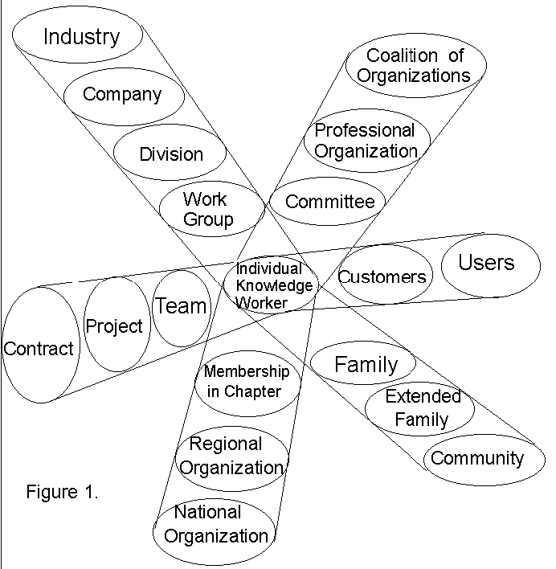

Figure One

A circle with radiating demarcated rays
Some recursive relationships, like government jurisdictions are neatly nested like a set of Russian dolls. Others, like coalitions or work teams have fluctuating boundaries. In each case, an identity is assumed which accepts some restraints on its autonomy in the interests of fitting into the larger system. Each also harmonizes the associated information and criteria of its different memberships - with more or less success.
People in any organization often have roles at more than one level of recursion. When this occurs, the same question may have different answers depending on the hat one is wearing. For example, a question about how extensively to document a process would depend on whether one's perspective is serving today's customers or integrating product lines from several divisions. The history of a project might be useful to a wider group - or a subgroup - within the organization. Some processes might be standardized and marketed as products in their own right. Others might expose the whole organization to liability when assessed according to a wider range of users or conception of risk. The implications could span many levels of recursion but might not be obvious from any single perspective.
When using the Viable System Model, it is often helpful to consider one level of recursion as the 'system in focus' and to explore the levels of recursion immediately above and below it. This becomes especially useful as complexity increases in an organization with multiple projects, sites or divisions.
Knowledge Management and the Big Picture
The knowledge that individuals and organizations have of themselves provides the framework in which they choose alternatives from among a huge, often uncountable, range of possibilities. Typically, self-knowledge is mediated by the culture and language in which discussions take place and the extent to which it is possible to integrate various perspectives and models in order to act as a purposeful entity.
Large organizations which have gotten into trouble often have done so because they behaved as if their size and their ability to do anything meant they could do everything. Recent management thinking has focused on reining in this tendency: determining core competencies and focusing on them, understanding how culture and values maintain processes and practices, and learning to make behaviour throughout the organization coherent and consistent. (Prahalad and Hamel, 1990, Hammer and Champy, 1993)
Getting a handle on the social and technical resources of knowledge in the organization is a necessary step. Certainly knowledge management is a big picture issue. Just as certainly, deficiencies here expose the organization to the risk of not recognizing opportunities or threats. If it is not known where knowledge assets are and how they are being utilized, much of their potential value may be wasted.
set in place by System Two working properly? Are the resource bargains made by System Three satisfactory? Are the questions asked by System Four with respect to present knowledge needed to make future plans being answered? Are risks to reputation and identity being monitored on behalf of System Five? Among the specific items System 3 Star might monitor are the status of patents and copyrights, quality control procedures, information technology usage, including e-mail security, accuracy of skill bank information, and the state of the organization's infrastructure.

