Symbols used in Genogram
A genogram is a graphic representation of a family tree that displays the interaction of generations within a family. It goes beyond a traditional family tree by allowing the user to analyze family, emotional and social relationships within a group. It is used to identify repetitive patterns of behavior and to recognize hereditary tendencies. Here are some of the basic components of a genogram.

Genogram Symbols
In a genogram, males are represented by a square and females by a circle. If you are unsure of the how to place individuals in complex family situations, such as reconstituted families, please visit the rules to build a genogram. GenoPro also has two other gender symbols, the diamond for a pet and the question mark for unknown gender.
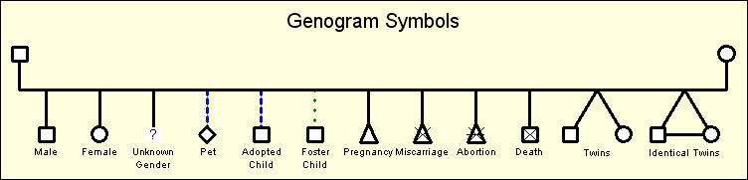
Standard Gender Symbols for a Genogram

In a standard genogram, there are three different types of children: biological/natural child, adopted child and foster child. A triangle is used to represent a pregnancy, a miscarriage or an abortion. In the case of a miscarriage, there is a diagonal cross drawn on top of the triangle to indicate death. Abortions have a similar display to miscarriages, only they have an additional horizontal line. A still birth is displayed by the gender symbol;
the diagonal cross remains the same size, but the gender symbol is twice as small.
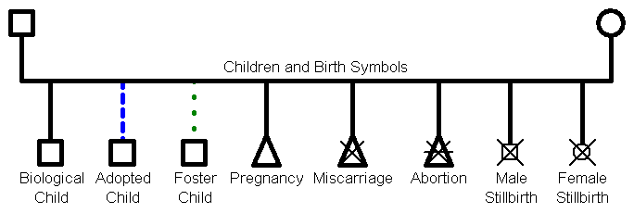
Genogram Symbols for Children's Links and Pregnancy Terminations

In the case of multiple births such as twins, triplets, quadruplets, quintuplets, sextuplets, septuplets, octuplets, or more, the child links are joined together. GenoPro uses the term twin to describe any type of multiple birth. With GenoPro, creating twins is as simple as a single click on the toolbar button "New Twins". GenoPro take cares of all the drawing, including joining the lines together. Identical twins (or triplets ...) are displayed by an horizontal line between the siblings. In the example below, the mother gave birth to fraternal twin brothers, identical twin sisters and triplets, one of whom died at birth.
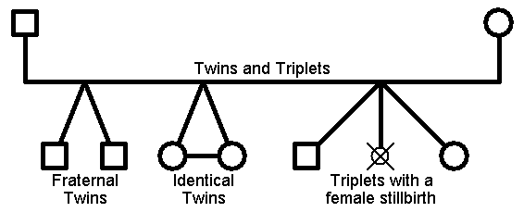
Child links are joined for multiple births such as twins and triplets
In addition to this, GenoPro supports medical genograms by using color codes and special drawing in the gender symbol. To learn more, please visit medical genograms.

Genogram Legend
At any time you can add a genogram legend by right-clicking on your mouse and selecting a new legend. The legend symbols have already been marked to be excluded from the report, so they will not appear when you generate a report.

