**Types of Social Enterprises**

* Trading Enterprises. ...
* Financial Institutions. ...
* Community Organizations. ...
* Non-Governmental Organizations (NGOs) and Charities.

**Triple bottom line (TBL)**

The triple bottom line is **a transformation framework for businesses and other organizations to help them move toward a regenerative and more sustainable future**. Tools within the triple bottom line help to measure, benchmark, set goals, improve, and eventually evolve toward more sustainable systems and models.

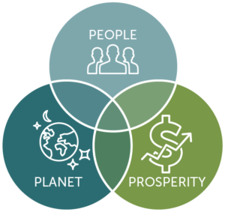

**Bottom of the pyramid (BoP)**

**By delivering innovative, technology-based solutions to the BoP, social entrepreneurs enhance the quality of life at the BoP**. Often, this means bringing low-cost, life-saving technologies to the Global South.

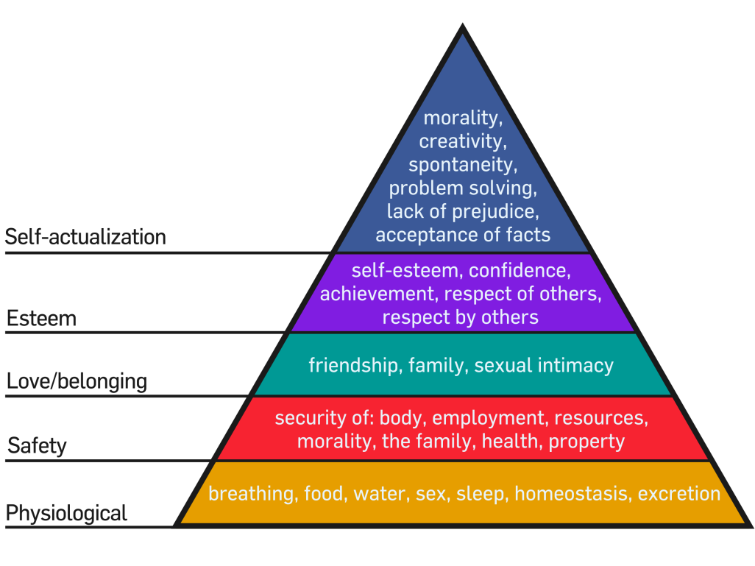

**Sustainopreneurship**

Sustainopreneurship (**entrepreneurship and innovation for sustainability**) is a concept that has emerged from the earlier concepts social entrepreneurship and ecopreneurship, via sustainability entrepreneurship.

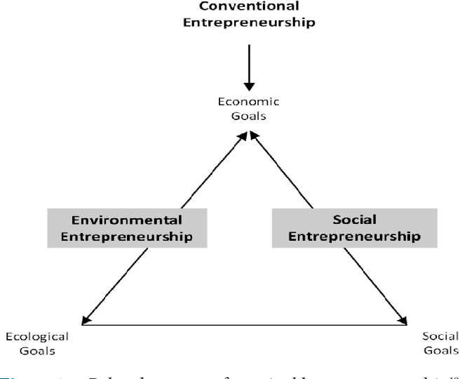

Corporate social responsibility is a form of international private business self-regulation which aims to contribute to societal goals of a philanthropic, activist, or charitable nature by engaging in or supporting volunteering or ethically-oriented practices.

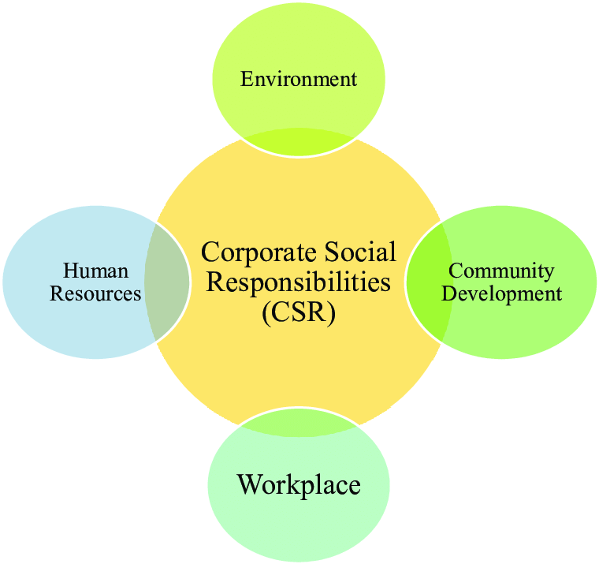

**Practice of Social Entrepreneurship in India (3 Cases)**

**Cases of Social Entrepreneurship:**

**Bangladesh Rural Advancement Committee (BRAC):**

The BRAC was established in 1972 by Fazle Abed, a Bangladeshi corporate executive, in the aftermath of the Independence War. Over the past 30 years, BRAC has focused on breaking the cycle of poverty in Bangladesh.

ADVERTISEMENTS:

Starting as a relief and resettlement organization, BRAC pioneered the development of comprehensive, locally organized approaches to rural development and poverty alleviation. It provides a range of services – rural capacity-building, education, health services, and micro-credit – to 2.6 million rural people, and it has been exceptionally successful in developing projects that contribute to its own financial sustainability.

**(a) Essential Innovation:**

Focuses on local constituent needs and capacities through a systemic approach to poverty alleviation that emphasizes systematic learning at many levels. Instituted rapid scaling up of the organization while ensuring sustainability.

**(b) Scope:**

Operates in 60,000 of the 86,000 villages in Bangladesh. Organizes the poor for self-help and builds local capacities for economic development, healthcare, and education. Focuses on working with women and other oppressed groups. Seeks to change local attitudes and culture for landless poor, and shift economic circumstances.

**The Grameen Bank (GB):**

The GB was established in 1976 by Mohammed Yunus, a Bangladeshi economics Professor, and his colleagues. Convinced that poor borrowers might be worthwhile credit risks, they demonstrated that landless women in mutually accountable borrower groups achieved very high repayment rates.

ADVERTISEMENTS:

The Grameen Bank forms small groups of five people to provide mutual, morally binding group guarantees in lieu of collateral. Past participants have proven to be reliable borrowers and astute entrepreneurs; as a result, they have raised their social status, lessened their dependency on their husbands, improved their homes, and provided better nutrition for their children.

These borrowers developed the social development guidelines known as the “Sixteen Decisions,” which have formed the basis of village group meetings throughout the Grameen system. Today, over 90% of the millions of micro-credit borrowers around the world are women.

**(a) Essential Innovation:**

Provides group lending for poor people without collateral. Succeeded in expanding organizational capacity to serve millions of small borrowers.

**(b) Scope:**

Provided small loans to 2.3 million very poor borrowers. Created 12 other businesses (e.g., fisheries, handloom factories, renewable energy plants) to serve the poor. Expanded poor women’s roles in income generation, as well as in micro­credit theory and practice around the world.

**The Self-employed Women’s Association (SEWA):**

The SEWA founded in 1972 by Ela Bhatt, is a trade union of women who earn their livelihoods in three broad occupational categories that, historically, have been very difficult to organize: Hawkers and vendors, home-based producers, and manual labourers and service providers.

ADVERTISEMENTS:

Their initial programs focused on improving members’ working conditions through influencing the actions of local police and policy makers. Later, SEWA provided a variety of services that were otherwise unavailable to their members.

With approximately 315,000 members, SEWA is the first and largest trade union of informal sector workers. In addition to its unionizing activities, SEWA has several “sister” institutions, including a bank that provides financial resources, an academy that provides teaching, training and research, and a housing trust that coordinates housing activities for its members. SEWA has become an international force, working with women’s and labour movements worldwide.

**(a) Essential Innovation:**

Organizes groups of women that are atomized and have little reason to cooperate for political change, or otherwise address economic, social, and health issues. Builds local leadership capacity to scale up organization and movement.

**(b) Scope:**

ADVERTISEMENTS:

Organized 315,000 self-employed women as union members. Improved working conditions, access to health care, credit, and savings for the more than 90% of India’s self-employed/unorganized, female labourers. Influenced the creation of self-employment labour division in the Indian government.

Influenced the International Labour Organization to pass standards for home workers (including minimum wage and working conditions). Co-founded international network to support the work of women in the informal sector (Women in Informal Employment Globalizing and Organizing, WIEGO).

Now, the above cases are compared on four aspects: the nature of innovations they have articulated, the characteristics of their leaders, the types of initiatives taken, and the paths chosen for scaling up their impacts.

**[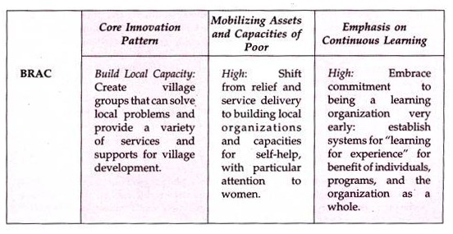](https://www.yourarticlelibrary.com/wp-content/uploads/2014/05/clip_image002170.jpg)**

**[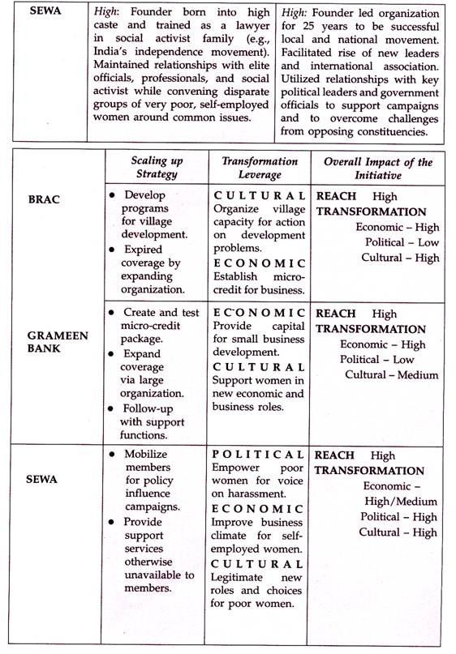](https://www.yourarticlelibrary.com/wp-content/uploads/2014/05/clip_image00626.jpg)**